CLOUD COMPLUTING

ASSIGNMENT - 2

EKS Cluster Nodes

EKS cluster worker nodes successfully provisioned and in Ready state. Two t3.medium EC2 instances running Kubernetes version 1.31 in the us-east-1 region, demonstrating successful cluster creation and node registration.

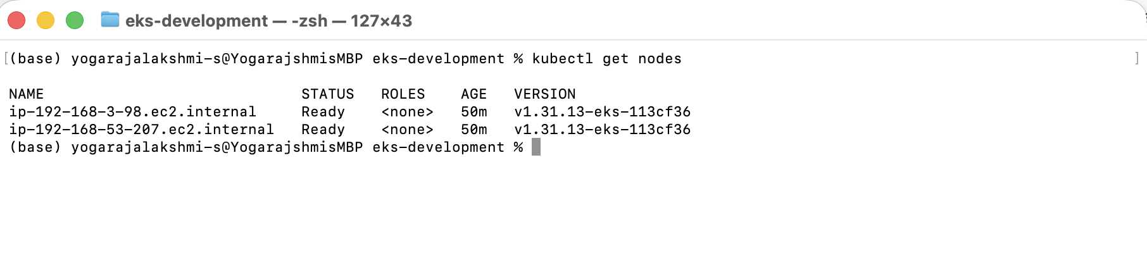

All Kubernetes Resources

Complete view of deployed Kubernetes resources showing deployments, services, pods, and replica sets. The flask-todo-app deployment has 2/2 replicas available, MongoDB has 1/1 replica, and both services (flask-todo-service as NodePort, mongodb-service as ClusterIP) are successfully configured.

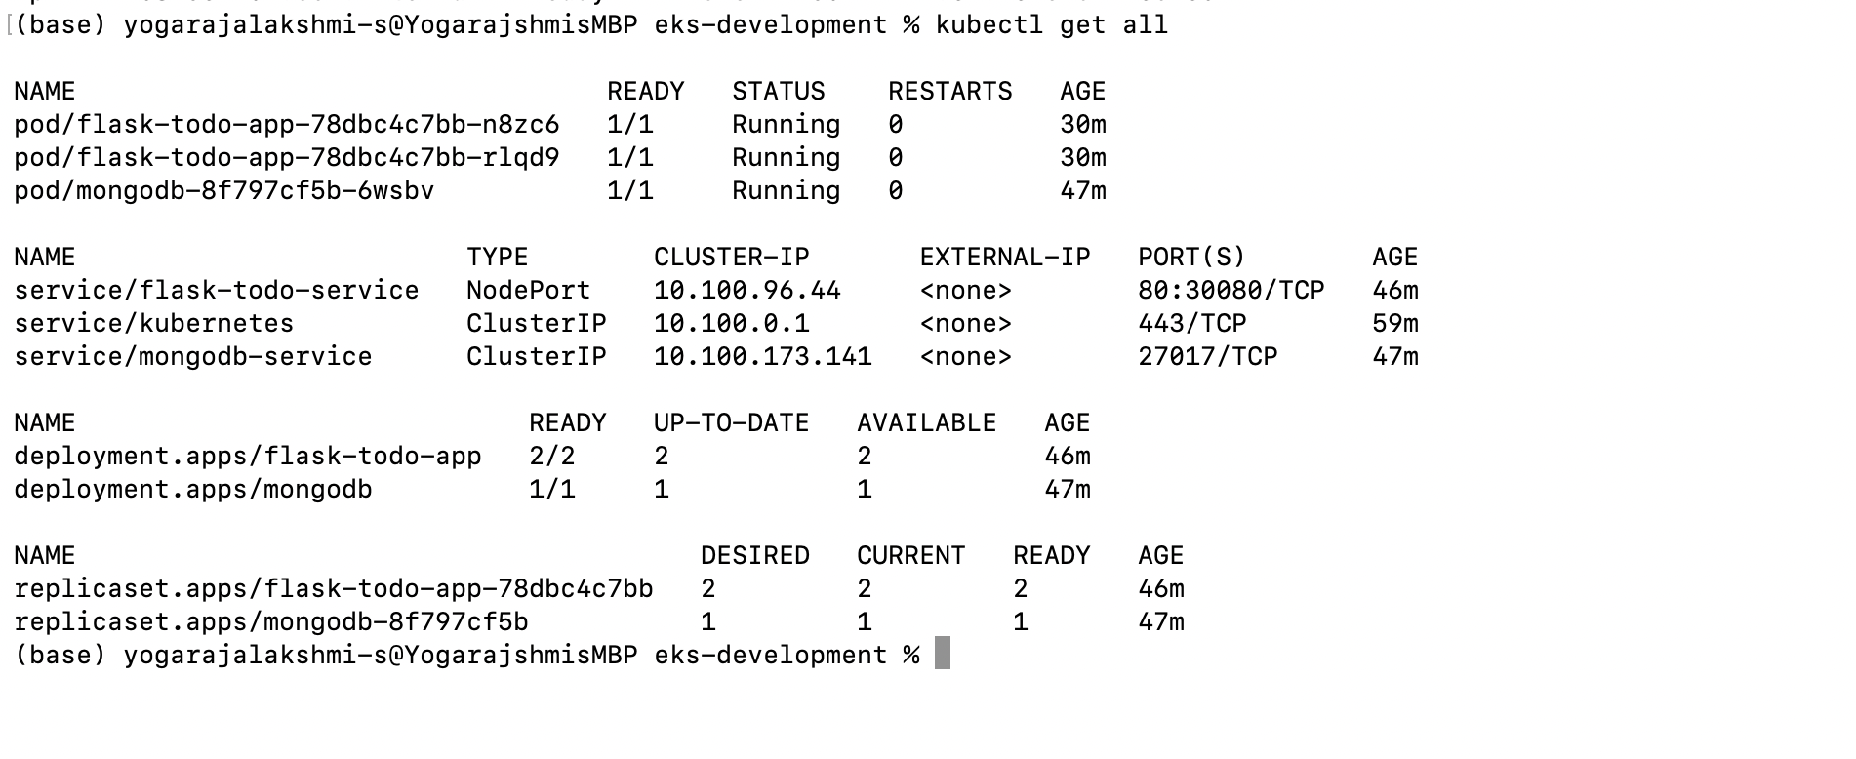Application URL in Browser

Flask To-Do application successfully accessible via public URL using NodePort service on port 30080. The application homepage loads correctly, demonstrating successful external access configuration through AWS security groups and Kubernetes NodePort service.

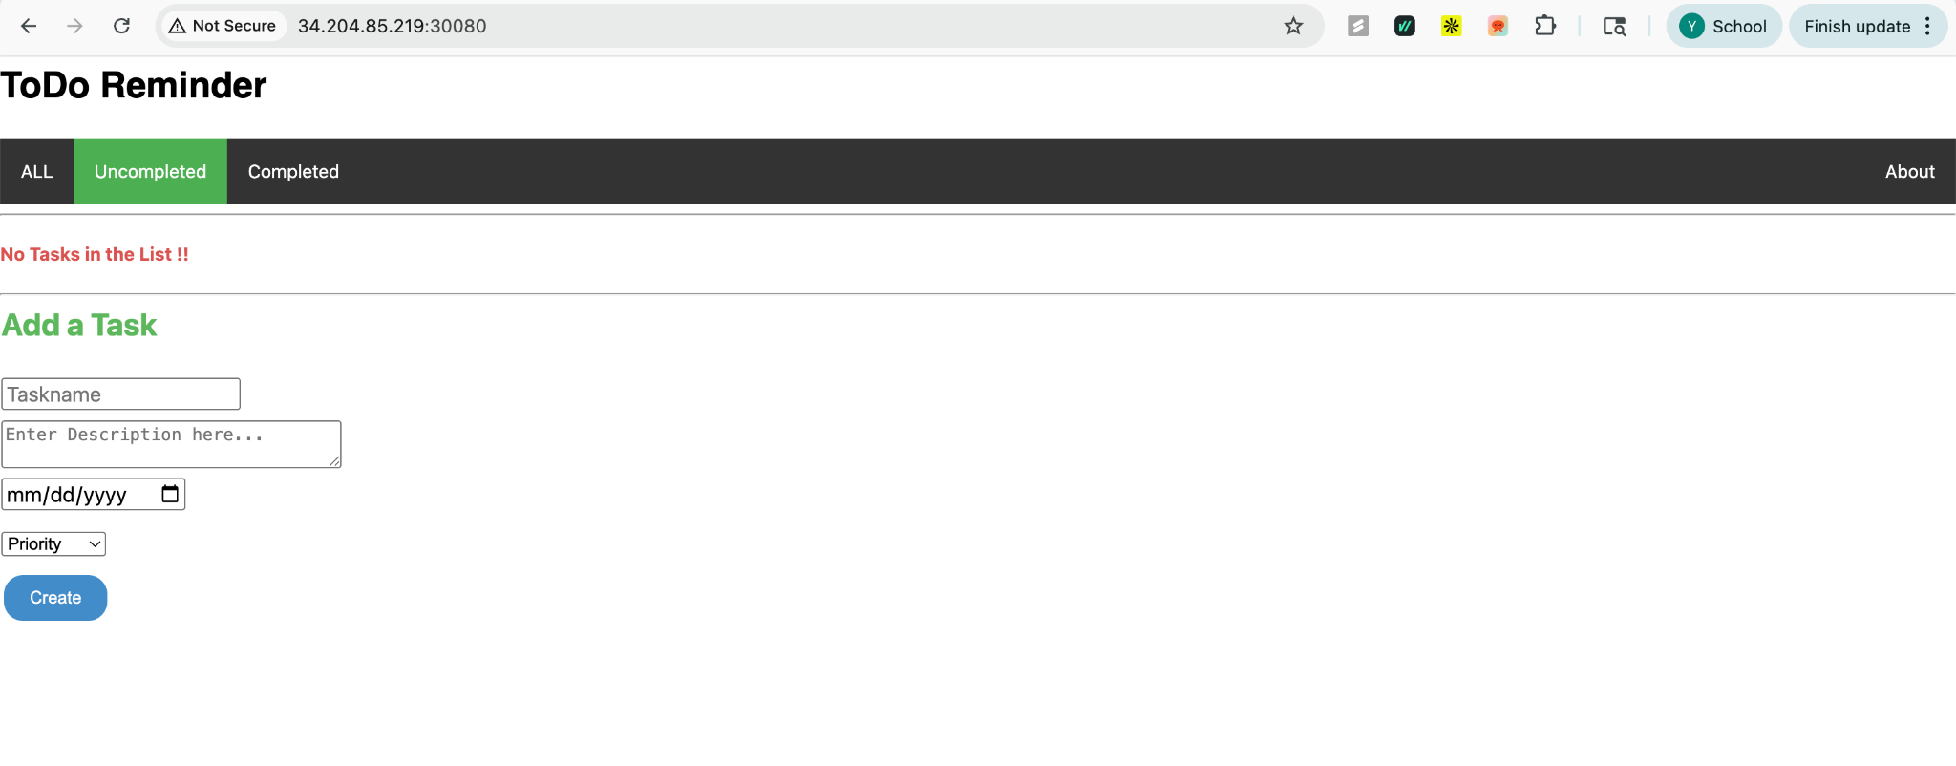

Application with Multiple Tasks

Functional demonstration of the To-Do application with multiple tasks created. Shows task management features including task name, description, due date, priority levels, and filtering options (All/Uncompleted/Completed). Data persists in MongoDB, demonstrating successful database connectivity and CRUD operations.

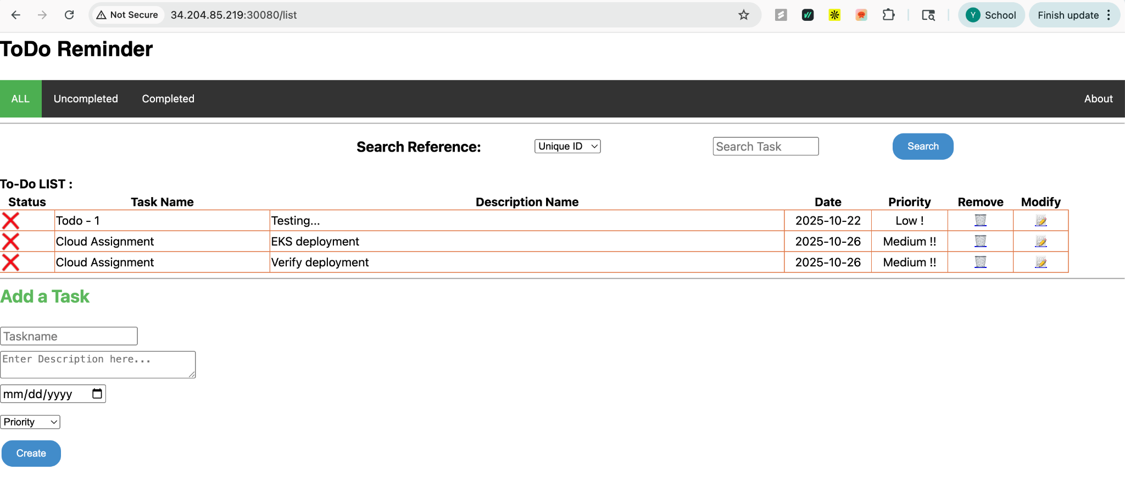

Task Marked as Complete

Task completion functionality demonstrated with a task marked as complete (indicated by checkmark/strikethrough). Shows the application's ability to update task status in MongoDB and reflect changes in the user interface in real-time, confirming successful database write operations.

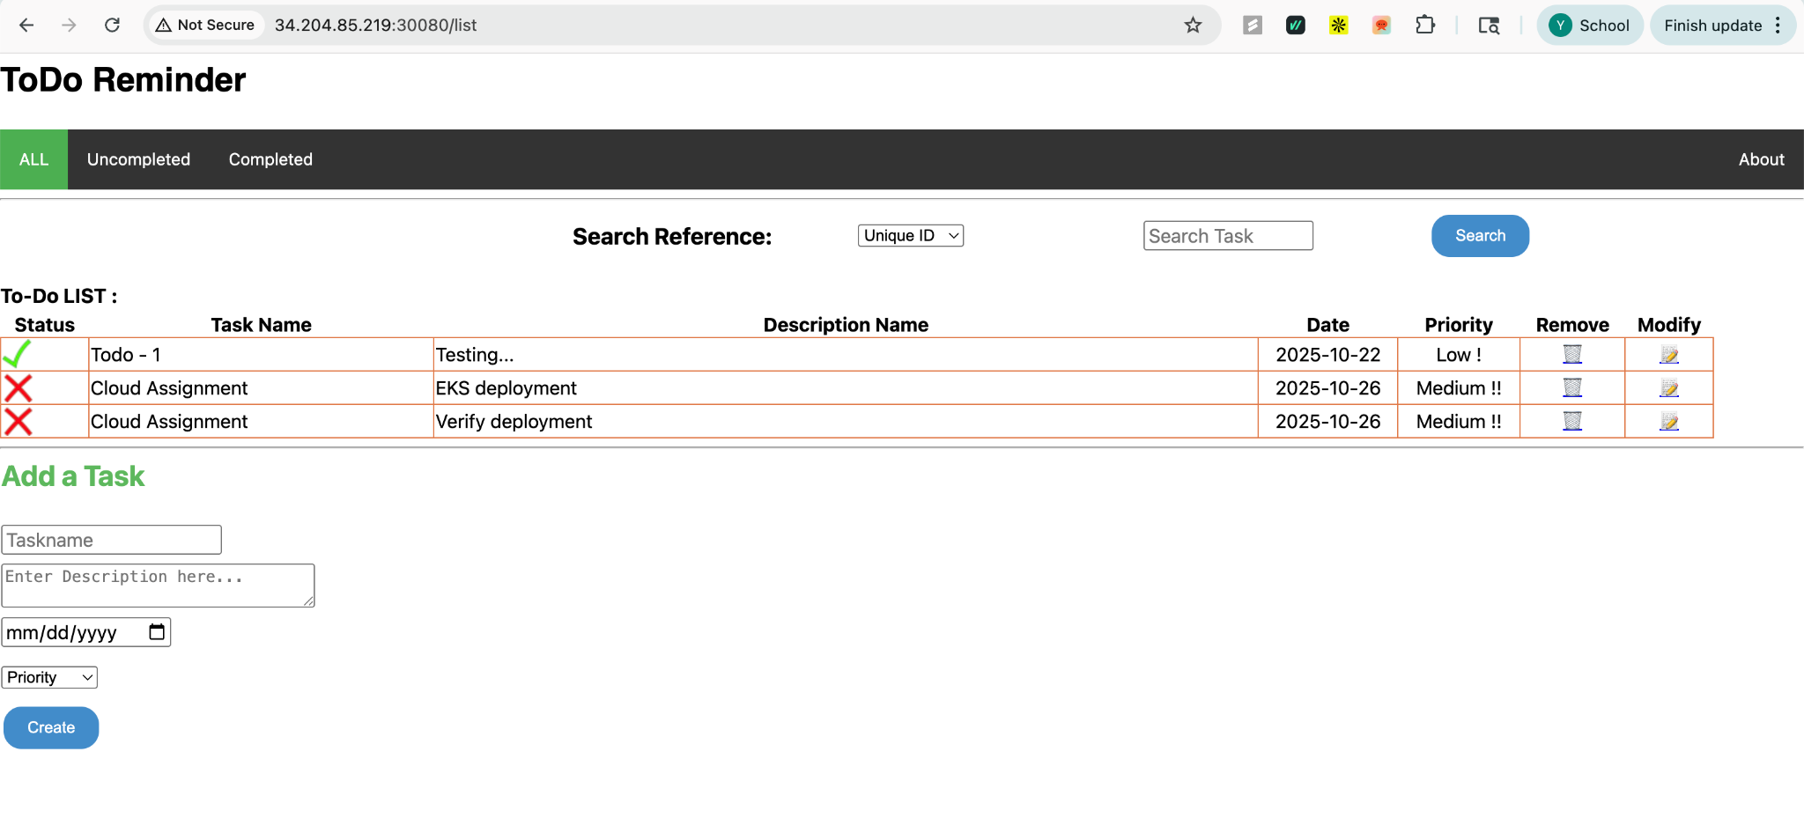

Deployment Details

Detailed deployment configuration showing Flask application deployment specifications including container image (yogas007/flask-todo-app:latest), environment variables (MONGO_URI, FLASK_ENV), resource limits (CPU: 200m, Memory: 256Mi), replica count (2), and rolling update strategy (maxUnavailable: 1, maxSurge: 1).

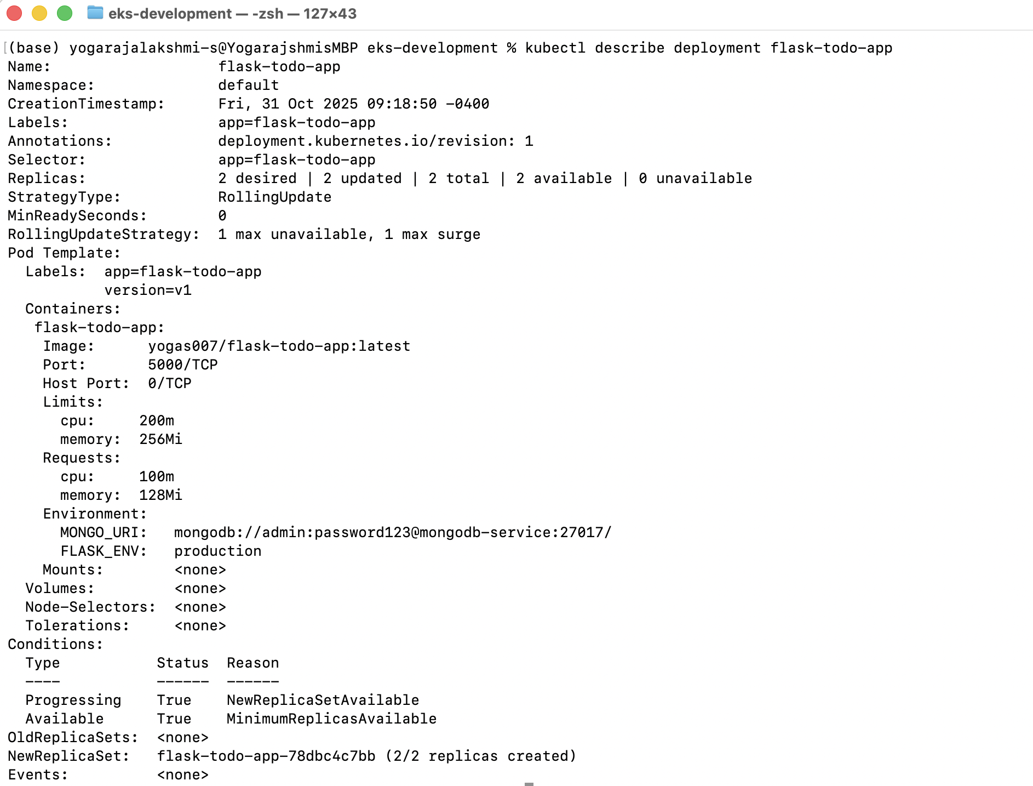

**Pods auto-created after deletion**

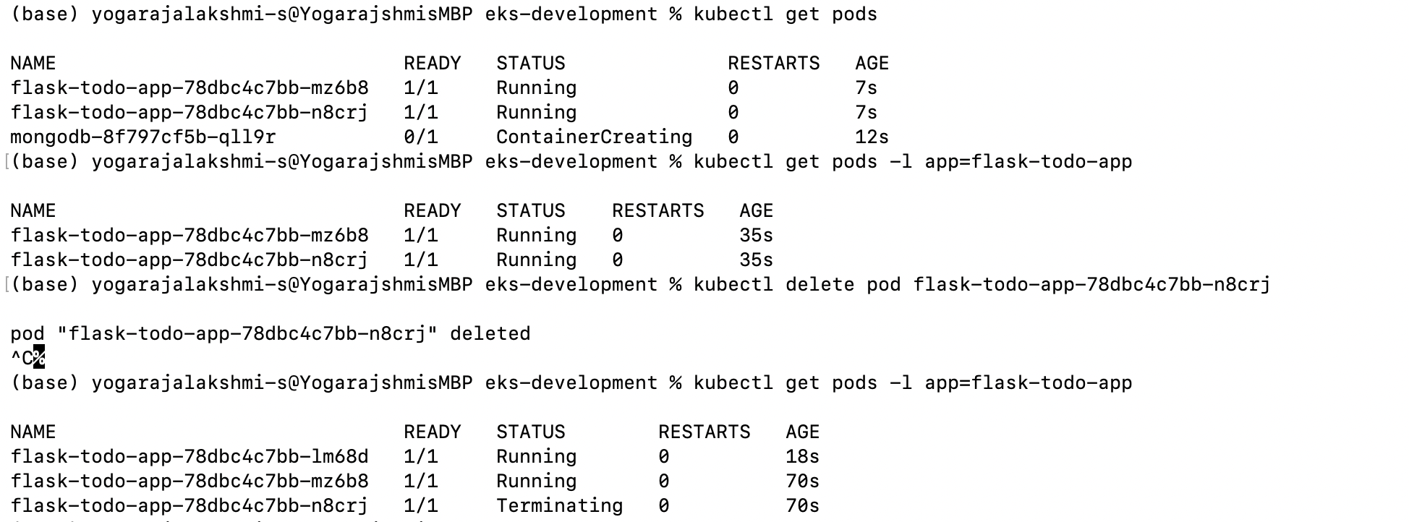

**Scaling from 2 - 4 pods**

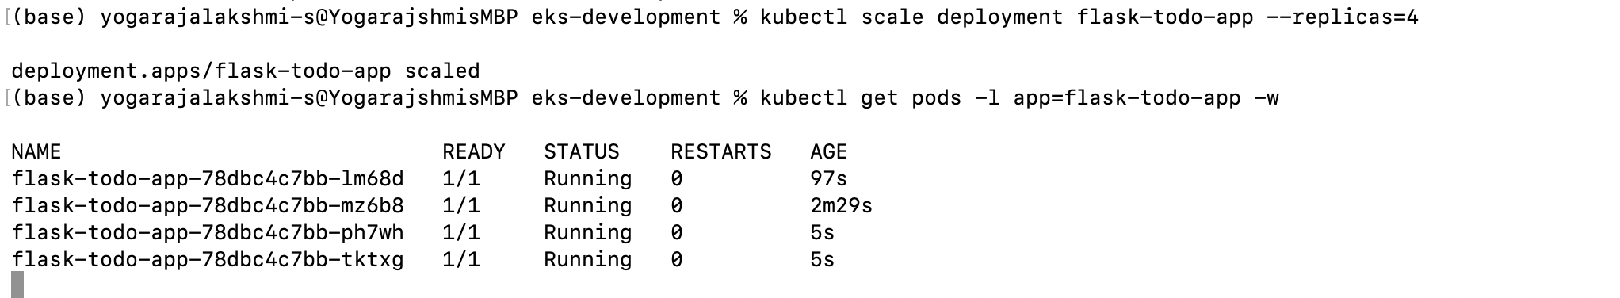

**Scaling down from 4 to 2**

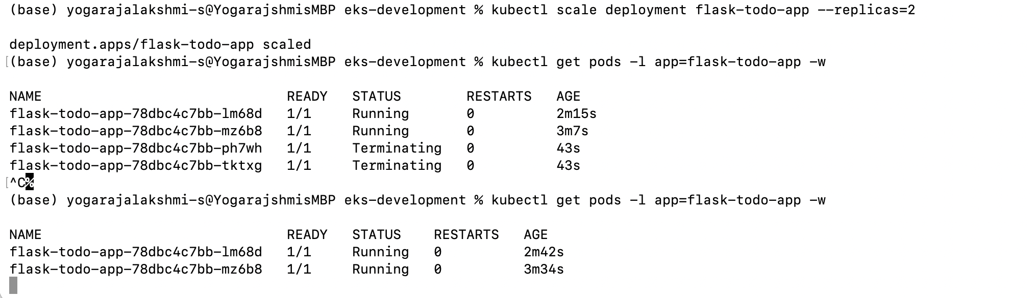

**Rollout update**

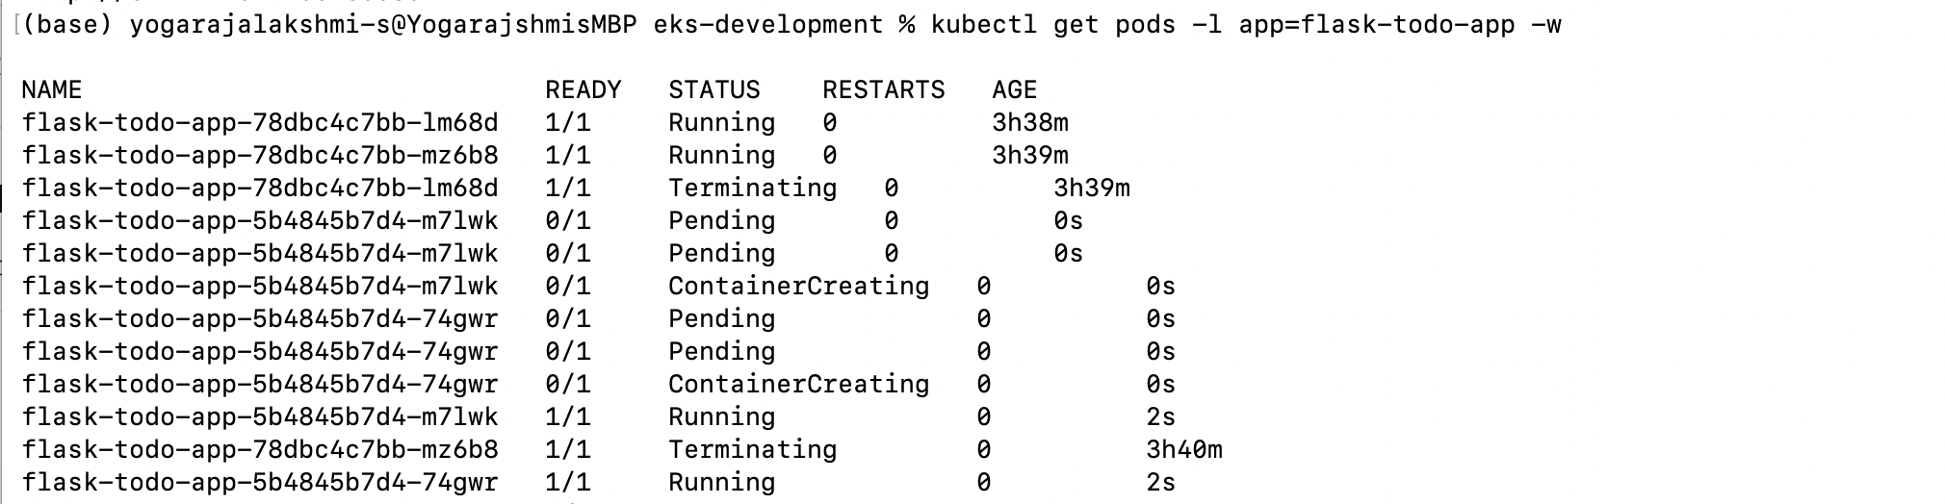

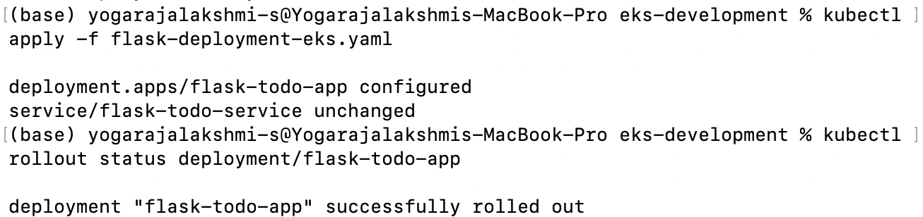

**Rollout history**

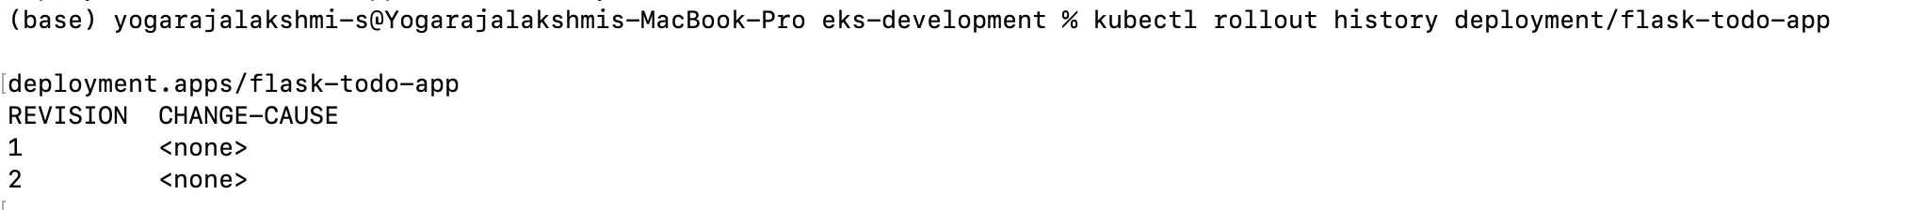

**Updating text to see if the app is updated**

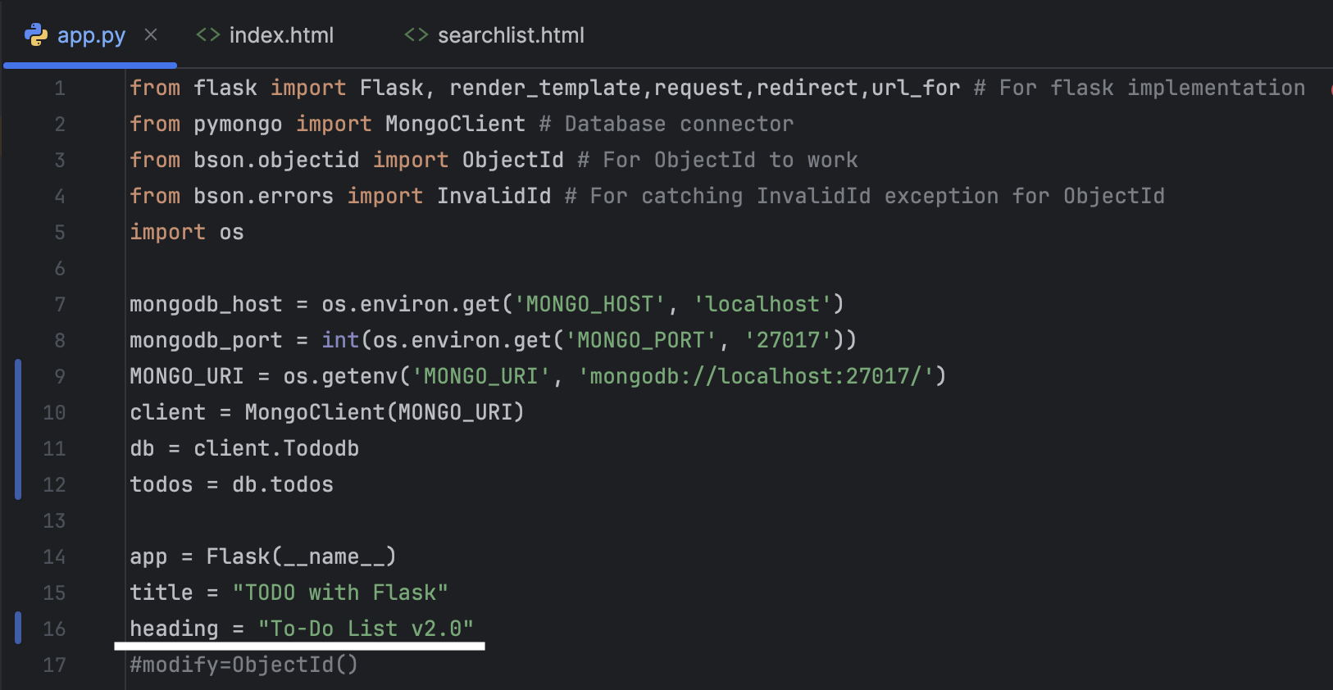

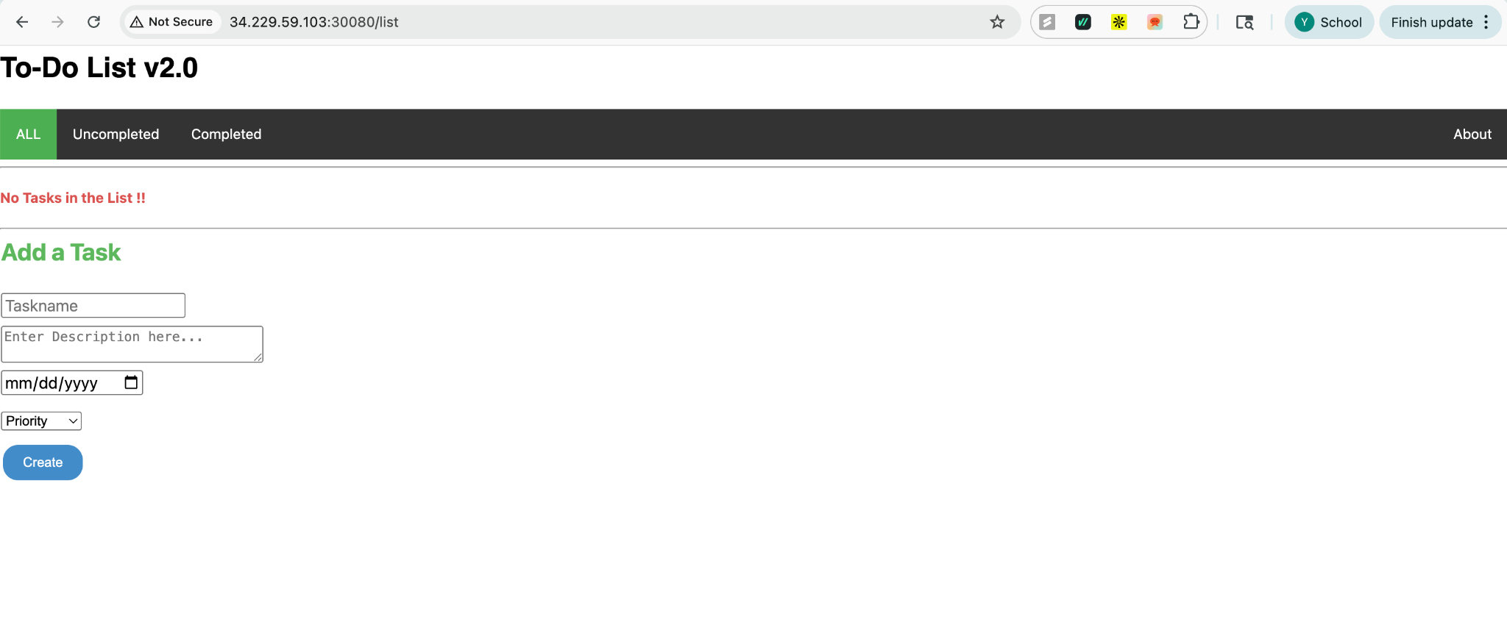

**Rollback the change**

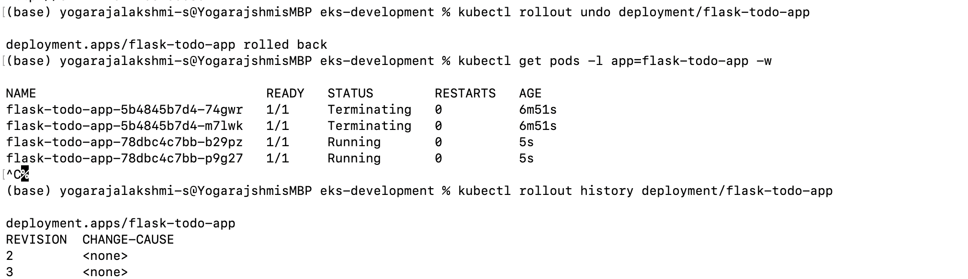

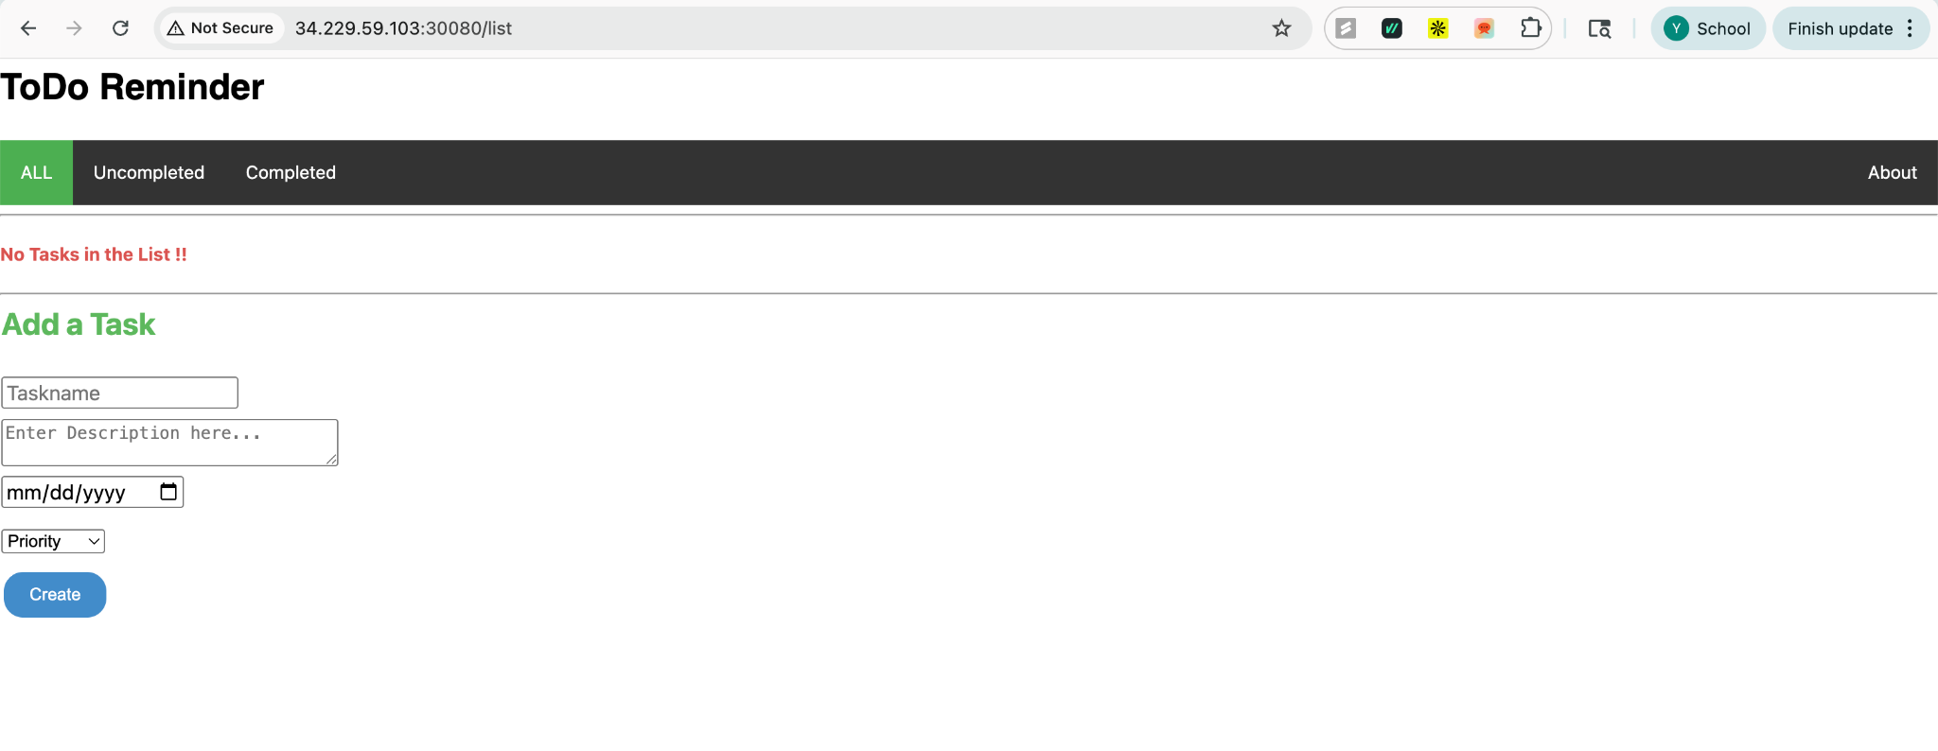

**Roll forward**

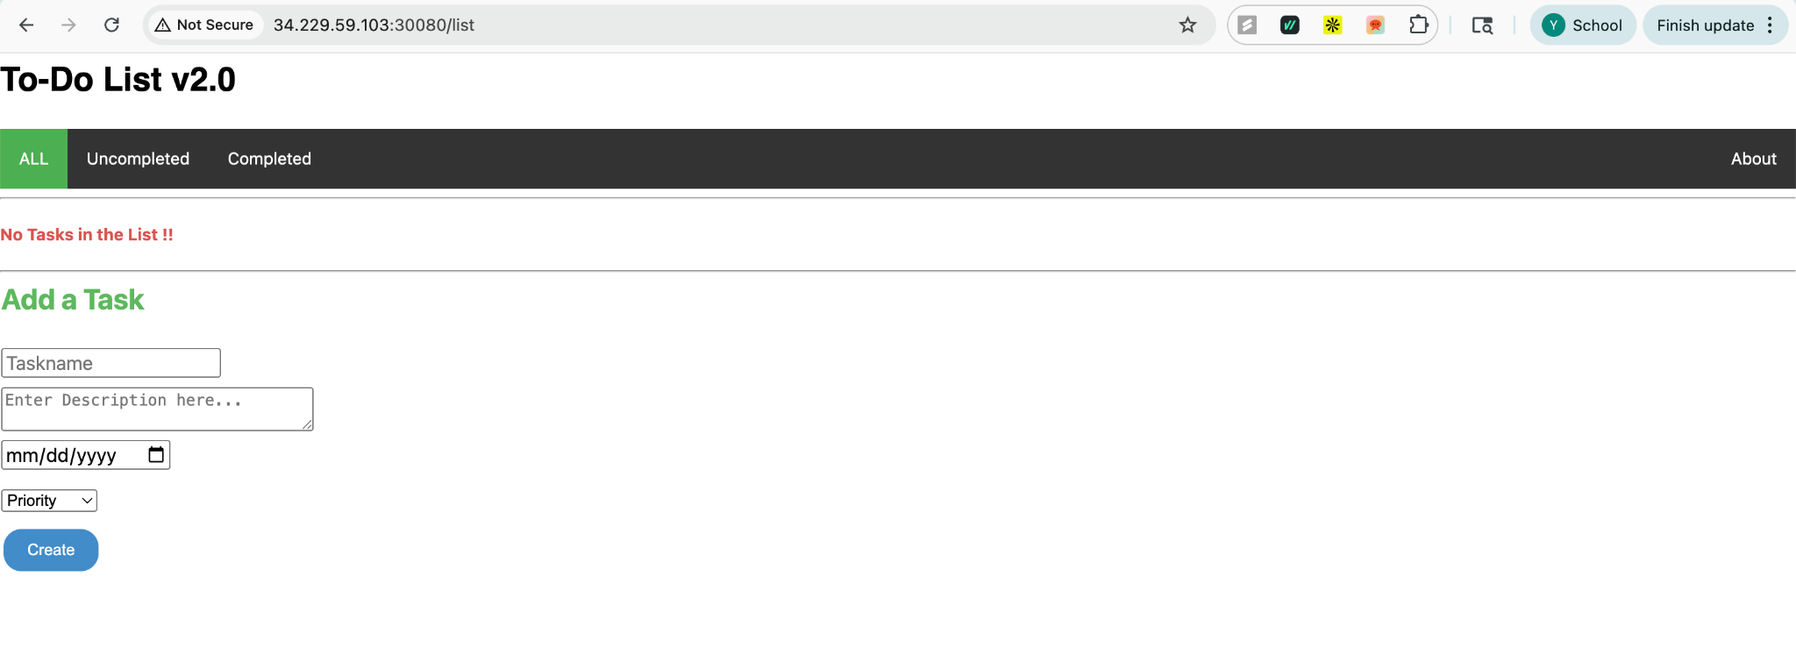

**flask-deployment-eks.yaml**

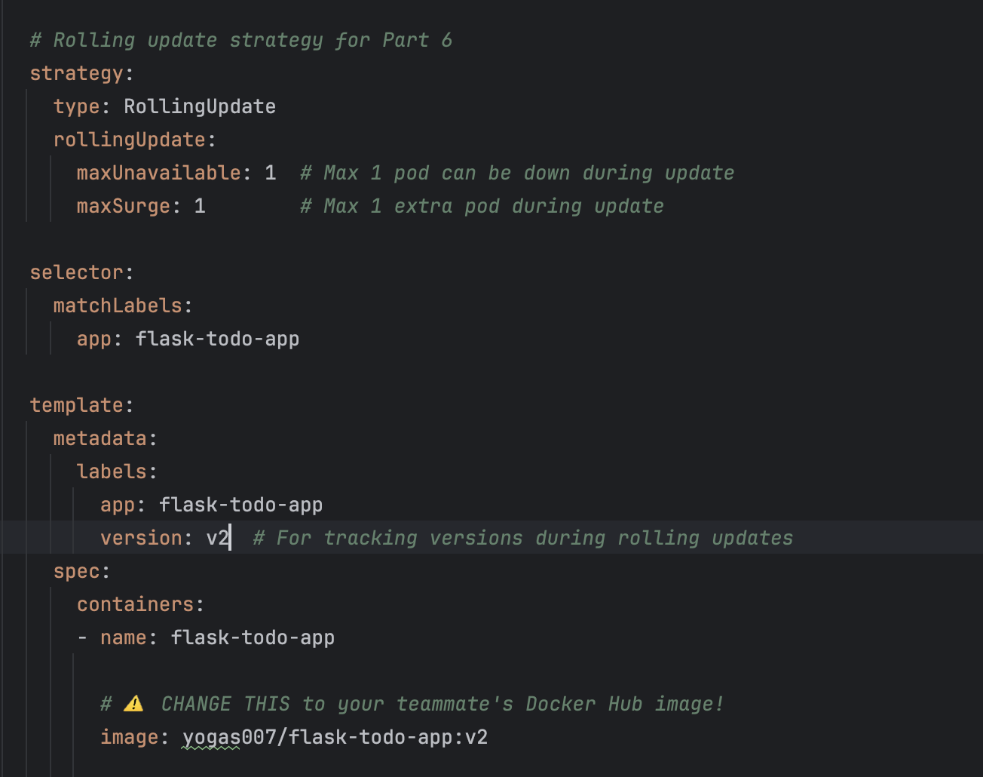

**Task 7 - Liveliness and Readiness probe**

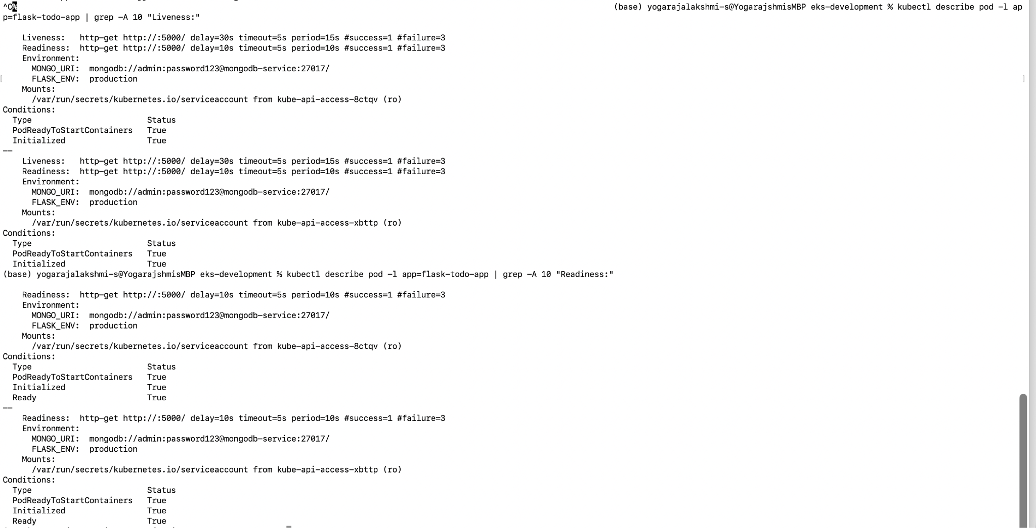

**Delete pod and see it recreating**

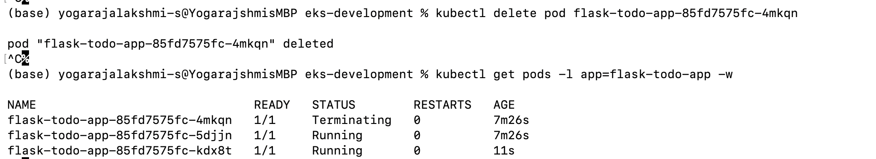

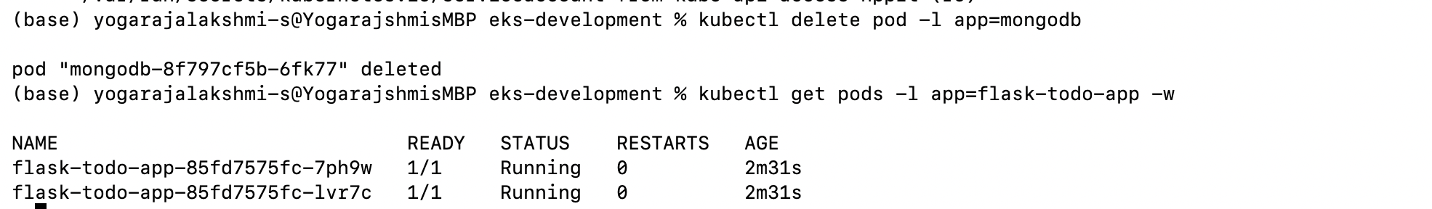

**Probe failures and restarts**

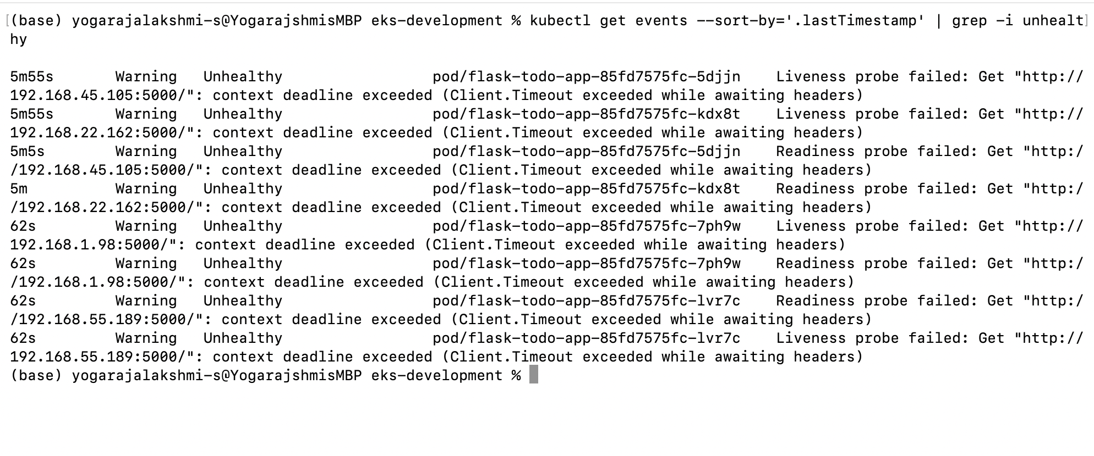

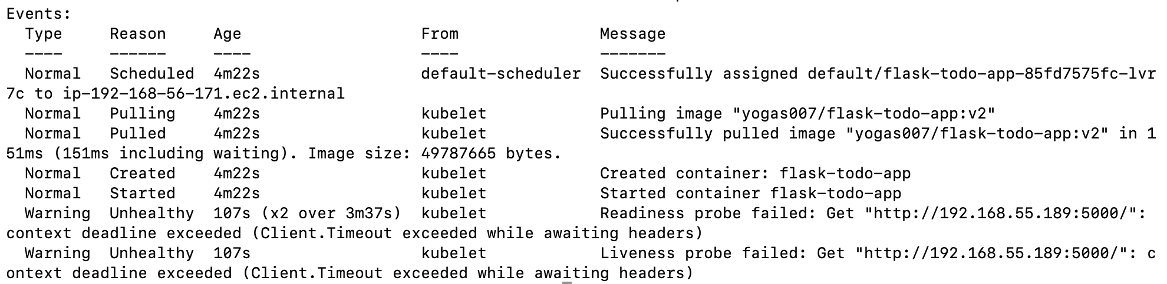

**Prometheus Alerts Page**

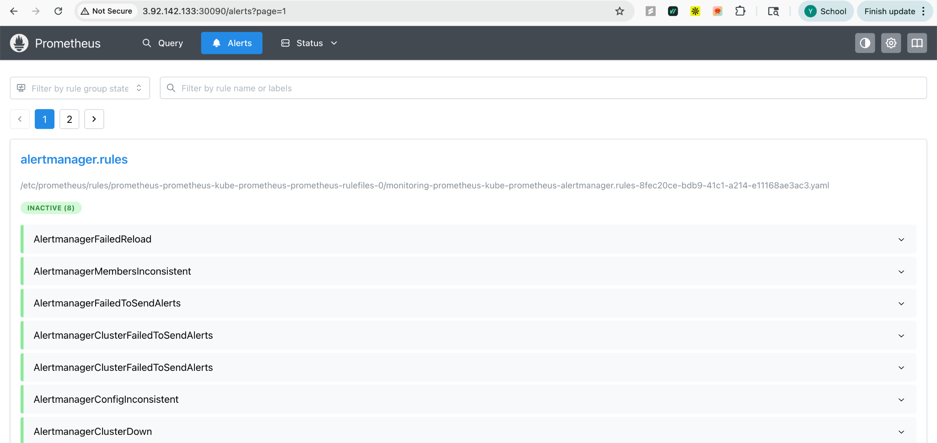

**Slack Configuration**

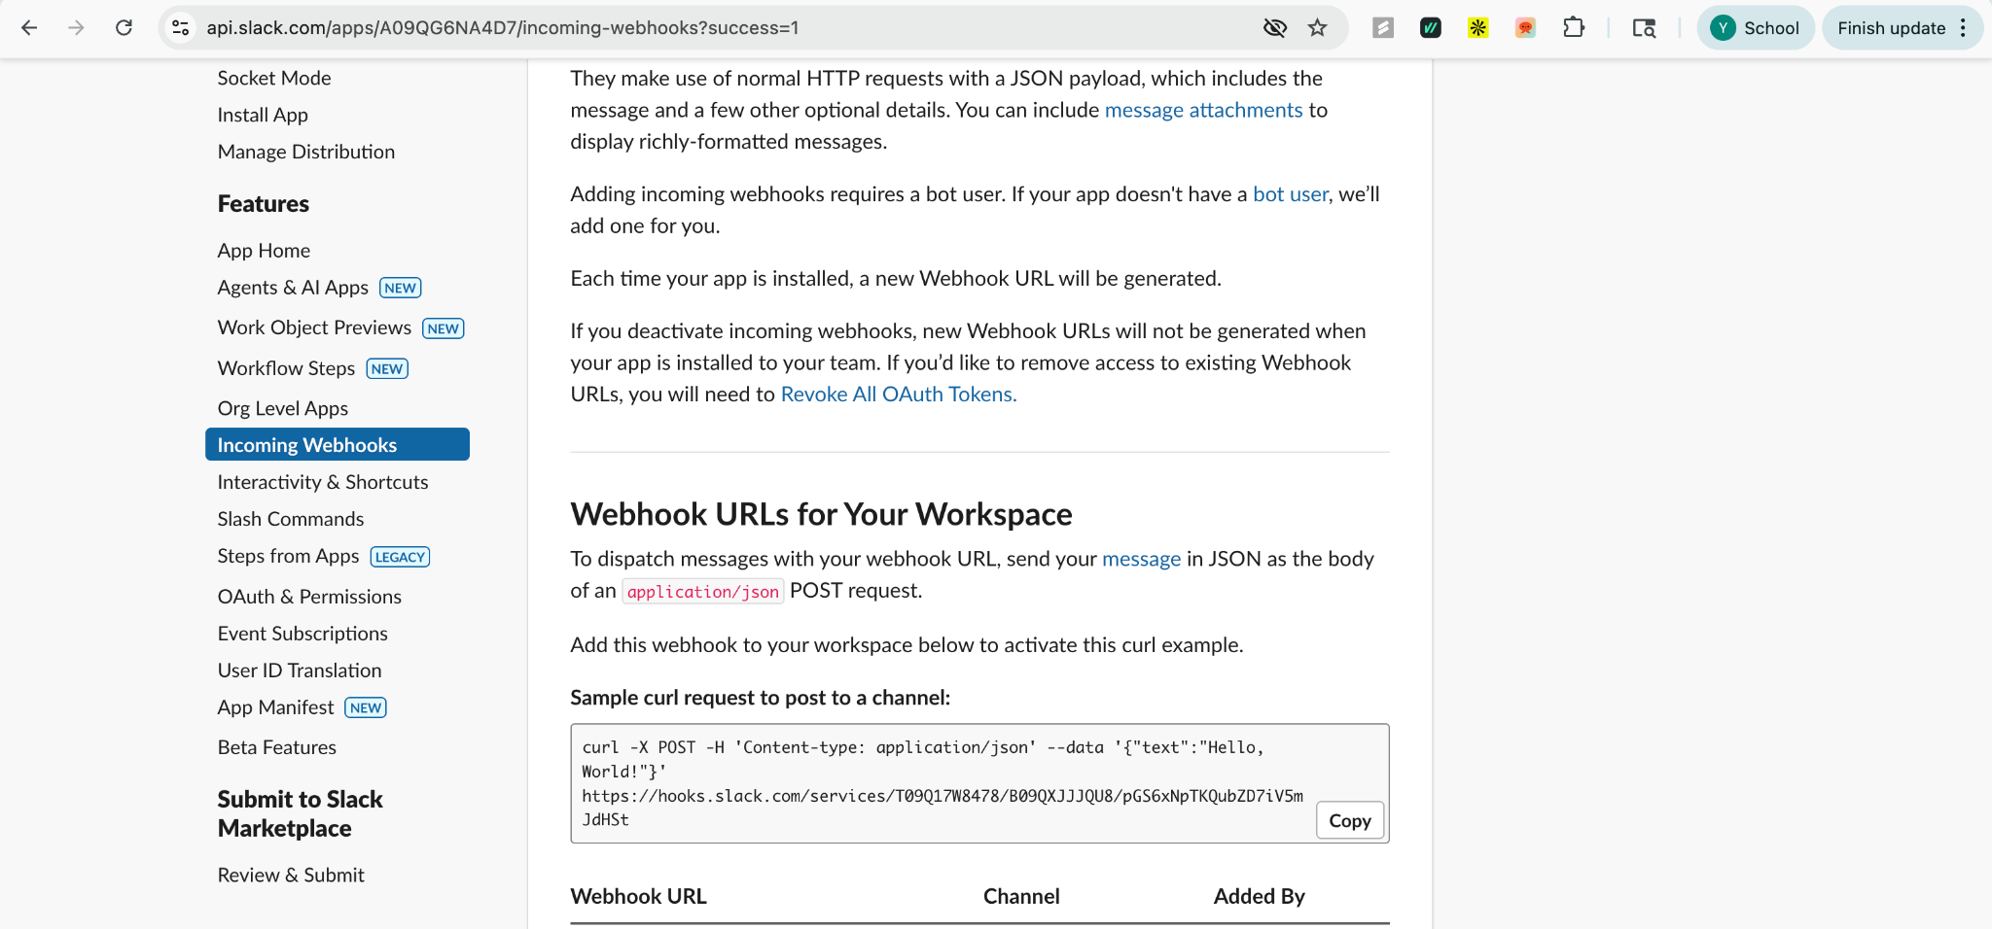

**Slack Alerts**

